**SITE EXAMPLES**

Phantasy style edges(pointed, border design, spiral)

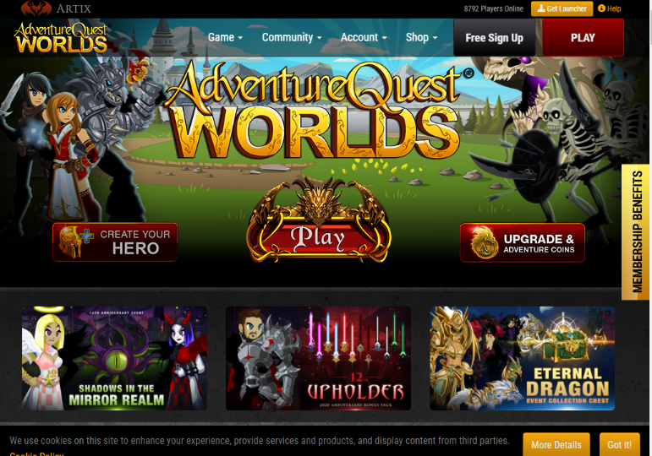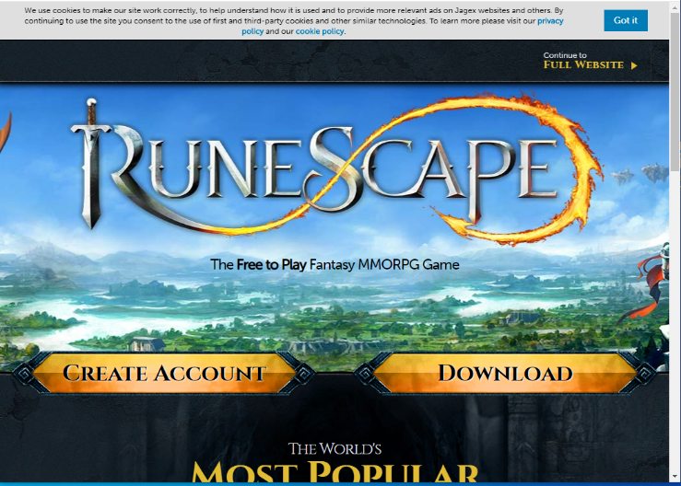

Clear in centre button

News/events

In corners(logo andlogin

Title on backdrop

login